**WEEKLY ASSESMENT -2**

**SQL queries**

1.select a.account_number, a.customer_number, c.firstname, c.lastname, a.account_opening_date

from account_master a

JOIN customer_master c ON a.customer_number = c.customer_number

ORDER BY a.account_number ASC;

2.select count(*) as Cust_Count from customer_master where CUSTOMER_CITY = "DELHI";

3.select a.customer_number, c.firstname, a.account_number from account_master a

JOIN customer_master c ON a.customer_number = c.customer_number

where day(a.account_opening_date) > 15

ORDER BY a.customer_number ASC, a.account_number ASC;

4.select count(*) AS Count_Customer from customer_master c

LEFT JOIN account_master a on c.customer_number = a.customer_number

where a.customer_number IS NULL;

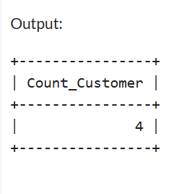

5.select t.transaction_type, count(*) as Trans_Count from transaction_details t

JOIN account_master a on t.account_number = a.account_number

where a.customer_number LIKE '%001'

GROUP BY t.transaction_type

ORDER BY t.transaction_type ASC;

